

**PROJECT**

**SCHOOL MANAGEMENT SYSTEM**

**Name –** Ritesh Tiwari

**Roll No -** c04201826

**Course -** CACPA

**Project Name-** School Management System

**Software use**

Visual Studio 2010, MS Access, Google Chrome , MS Word, Windows 10

**Hardware use**

Mouse, Keyboard, printer, CD;

Contents

Login page------------ 4

Page source: 4

Program Code’s: 6

Home Page--------- 8

Page source: 8

Student page------ 11

Page Source: 11

Program code’s 14

New Records----- 15

Page Source: 15

Program Code’s: 21

Update Records------- 22

Page Source: 22

Program Code’s: 28

Installment page---------- 30

Page Source: 30

Program codes: 35

User Page------------- 36

Page Source: 36

Programs codes: 41

# Login page------------

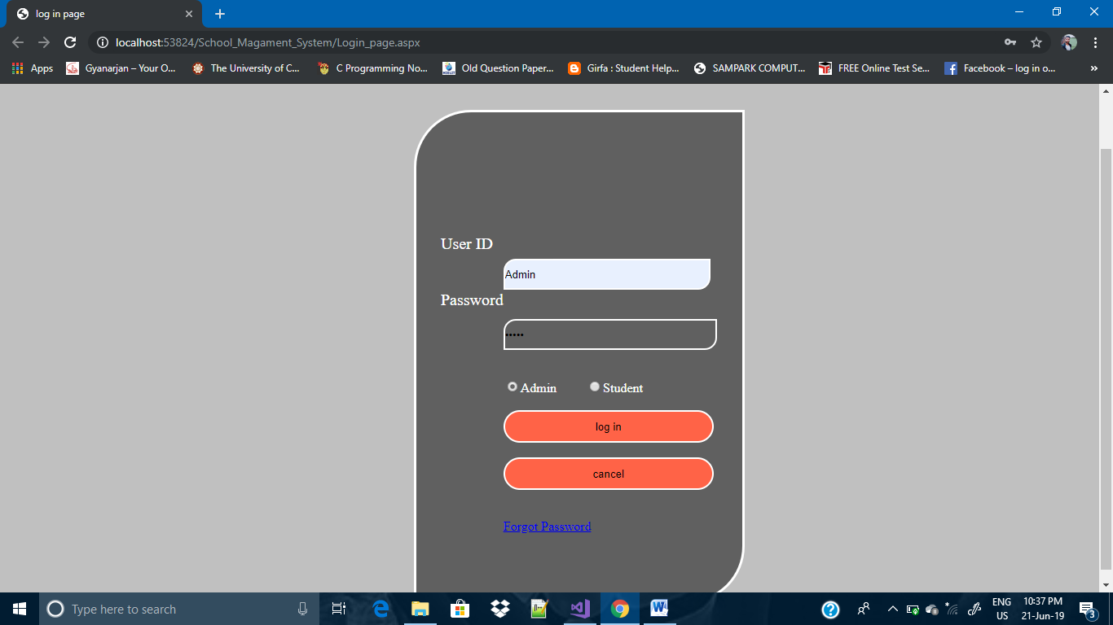

## Page source:

<%@ Page Language="C#" AutoEventWireup="true" CodeFile="Login_page.aspx.cs" Inherits="Login_page" %>

<!DOCTYPE html PUBLIC "-//W3C//DTD XHTML 1.0 Transitional//EN" "http://www.w3.org/TR/xhtml1/DTD/xhtml1-transitional.dtd">

<html xmlns="http://www.w3.org/1999/xhtml">

<head runat="server">

<title>log in page</title>

<style>

body

{

background-color:Silver;

}

.Login

{

height:500px;

width:400px;

margin-left:500px;

margin-top:100px;

background-color:rgba(0,0,0,0.5);

color:White;

border-radius:70px 0px 70px 0px;

border:3px solid #fff;

padding-top:100px;

position:absolute;

}

.text

{

font-size:20px;

padding-left:30px;

padding-top:50px;

float:left;

}

.textBox

{

margin-top:80px;

float:left;

}

#TextBox1

{

height:32px;

width:250px;

background-color:transparent;

border-radius:15px 0px 15px 0px;

border:2px solid #fff;

margin-bottom10px;

}

#TextBox2

{

height:32px;

width:100%;

background-color:transparent;

border-radius:15px 0px 15px 0px;

border:2px solid #fff;

}

#Button1

{

width:100%;

height:40px;

background-color:Tomato;

border-radius:40px 40px 40px 40px;

border:2px solid #fff;

}

#Button2

{

width:100%;

height:40px;

background-color:Tomato;

border-radius:40px 40px 40px 40px;

border:2px solid #fff;

}

#HyperLink1

{

}

</style>

</head>

<body>

<form id="form1" runat="server">

<div class="Login">

<div class="text" >

<asp:Label ID="Label2" runat="server" Text="User ID"></asp:Label>

<br /><br /><br />

<asp:Label ID="Label3" runat="server" Text="Password"></asp:Label>

</div>

<div class="textBox">

<asp:TextBox ID="TextBox1" runat="server"></asp:TextBox>

<br /><br /><br />

<asp:TextBox ID="TextBox2" runat="server" TextMode="Password"></asp:TextBox>

<br /><br />

<br />

<asp:RadioButton ID="RadioButton1" runat="server" Text="Admin" />

&nbsp;&nbsp;&nbsp;&nbsp;&nbsp;&nbsp;&nbsp;

<asp:RadioButton ID="RadioButton2" runat="server" Text="Student" />

<br />

<br />

<asp:Button ID="Button1" runat="server" Text="log in" onclick="Button1_Click" />

<br /><br />

<asp:Button ID="Button2" runat="server" Text="cancel" />

<br /><br />

<div>

<br />

<asp:HyperLink ID="HyperLink1" runat="server" NavigateUrl="~/Forgot_password.aspx">Forgot Password</asp:HyperLink>

<br /><br />

<asp:Label ID="msg" runat="server" Text=""></asp:Label>

</div>

</div>

</form>

</body>

</html>

## Program Code’s:

using System;

using System.Collections.Generic;

using System.Linq;

using System.Web;

using System.Web.UI;

using System.Web.UI.WebControls;

using System.Data;

using System.Data.OleDb;

public partial class Login_page : System.Web.UI.Page

{

string account;

protected void Page_Load(object sender, EventArgs e)

{

}

protected void Button1_Click(object sender, EventArgs e)

{

OleDbConnection con = new OleDbConnection("Provider=Microsoft.Jet.OLEDB.4.0;Data Source=" + @"D:\Ritesh Tiwari\ASP\School.mdb");

con.Open();

if (RadioButton1.Checked)

{

account = "Admin";

}

else if(RadioButton2.Checked)

{

account = "Student";

}

OleDbCommand com = new OleDbCommand("Select *from UserId_Password where User_ID='" + TextBox1.Text + "'and Password='" + TextBox2.Text + "'and Account='"+account+"'", con);

OleDbDataReader reader;

reader = com.ExecuteReader();

int count = 0;

while (reader.Read())

{

count++;

}

if (TextBox1.Text == "" && TextBox2.Text == "")

{

msg.Text = "Enter User ID Amd Password..............";

}

else if (count == 0)

{

msg.Text = "Wrong User ID Amd Password..............";

}

else

{

if (RadioButton1.Checked)

{

Response.Redirect("Home.aspx");

}

else

{

Response.Redirect("User_Page.aspx?a="+TextBox1.Text);

}

}

}

}

# Home Page---------

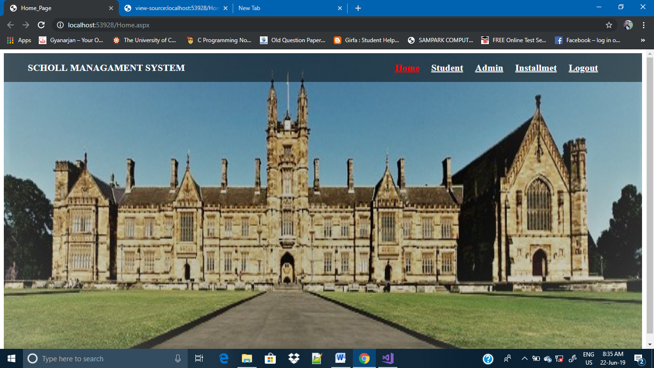

## Page source:

|  |  |
| --- | --- |
|  |  |
|  |  |
|  | <!DOCTYPE html PUBLIC "-//W3C//DTD XHTML 1.0 Transitional//EN" "http://www.w3.org/TR/xhtml1/DTD/xhtml1-transitional.dtd"> |
|  |  |
|  | <html xmlns="http://www.w3.org/1999/xhtml"> |
|  | <head><title> |
|  | Home_Page |
|  | </title> |
|  | <script type="text/javascript" src="<http://gc.kis.v2.scr.kaspersky-labs.com/FD126C42-EBFA-4E12-B309-BB3FDD723AC1/main.js>" charset="UTF-8"></script><style> |
|  | .Background |
|  | { |
|  | background-image:url(image/bgimage.jpg); |
|  | background-size:100% 110%; |
|  | background-position:100% 100%; |
|  | height:100vh; |
|  | width:100%; |
|  | } |
|  | .Menu |
|  | { |
|  | background-color:rgba(0,0,0,0.5); |
|  | color:White; |
|  | height:60px; |
|  | width:100%; |
|  |  |
|  |  |
|  | } |
|  | .leftmenu |
|  | { |
|  | width:35%; |
|  | line-height:60px; |
|  | padding-left:50px; |
|  | font-size:20px; |
|  | font-weight:bold; |
|  | float:left; |
|  | } |
|  |  |
|  | .rightmenu |
|  | { |
|  | width:60%; |
|  | line-height:60px; |
|  | padding-left:500px; |
|  | font-size:20px; |
|  | font-weight:bold; |
|  |  |
|  | } |
|  | #HyperLink1 |
|  | { |
|  | margin-left:300px; |
|  | } |
|  | #HyperLink2 |
|  | { |
|  | margin-left:20px; |
|  | }#HyperLink3 |
|  | { |
|  | margin-left:20px; |
|  | }#HyperLink4 |
|  | { |
|  | margin-left:20px; |
|  | } |
|  | #HyperLink5 |
|  | { |
|  | margin-left:20px; |
|  | } |
|  | </style> |
|  | </head> |
|  | <body> |
|  | <form name="form1" method="post" action="./Home.aspx" id="form1"> |
|  | <div> |
|  | <input type="hidden" name="__VIEWSTATE" id="__VIEWSTATE" value="/wEPDwUKMTMxNTYyOTc1N2RkkNGJo5SL+TOic8l3n+6Bs4HtZNsjVWu485RLeSH8swU=" /> |
|  | </div> |
|  |  |
|  | <div> |
|  |  |
|  | <input type="hidden" name="__VIEWSTATEGENERATOR" id="__VIEWSTATEGENERATOR" value="8D0E13E6" /> |
|  | </div> |
|  | <div class="Background"> |
|  | <div class="Menu"> |
|  | <div class="leftmenu"> |
|  |  |
|  | <span id="Label1">SCHOLL MANAGAMENT SYSTEM</span> |
|  | </div > |
|  | <div class="rightmenu"> |
|  | <a id="HyperLink1" href="[Home.aspx](http://localhost:53928/Home.aspx)" style="color:Red;">Home</a> |
|  | <a id="HyperLink2" href="[Student.aspx](http://localhost:53928/Student.aspx)" style="color:White;">Student</a> |
|  | <a id="HyperLink3" href="[Admin.aspx](http://localhost:53928/Admin.aspx)" style="color:White;">Admin</a> |
|  | <a id="HyperLink5" href="[Installment.aspx](http://localhost:53928/Installment.aspx)" style="color:White;">Installmet</a> |
|  | <a id="HyperLink4" href="[Login_page.aspx](http://localhost:53928/Login_page.aspx)" style="color:White;">Logout</a> |
|  | </div> |
|  |  |
|  | </div> |
|  | </div> |
|  |  |
|  | </form> |
|  | </body> |
|  | </html> |
|  |  |

# Student page------

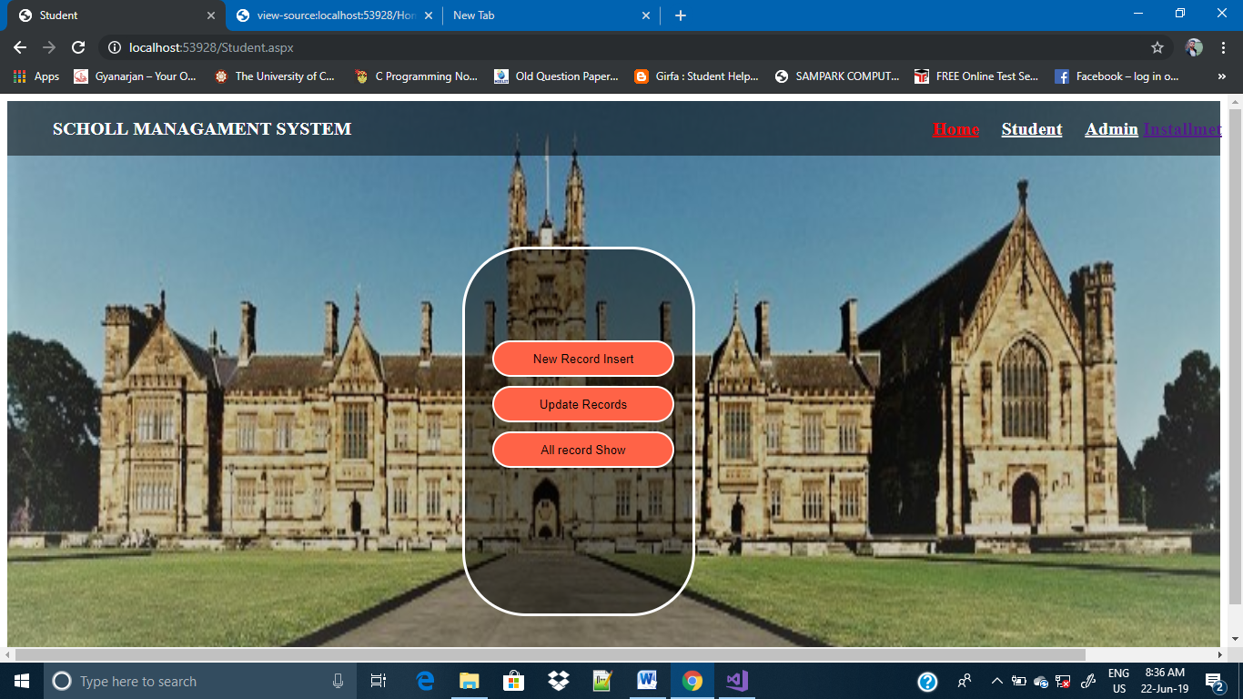

## Page Source:

<%@ Page Language="C#" AutoEventWireup="true" CodeFile="Student.aspx.cs" Inherits="Student" %>

<!DOCTYPE html PUBLIC "-//W3C//DTD XHTML 1.0 Transitional//EN" "http://www.w3.org/TR/xhtml1/DTD/xhtml1-transitional.dtd">

<html xmlns="http://www.w3.org/1999/xhtml">

<head runat="server">

<title>Student</title>

<style>

.Background

{

background-image:url(image/bgimage.jpg);

background-size:100% 110%;

background-position:100% 100%;

height:100vh;

width:100%;

}

.Menu

{

background-color:rgba(0,0,0,0.5);

color:White;

height:60px;

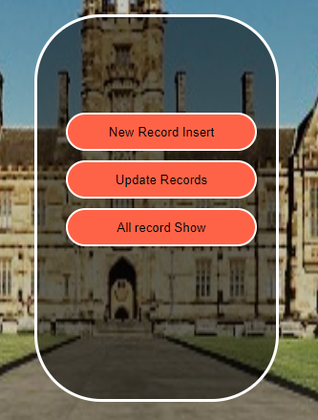 width:100%;

}

.leftmenu

{

width:35%;

line-height:60px;

padding-left:50px;

font-size:20px;

font-weight:bold;

float:left;

}

.rightmenu

{

width:75%;

line-height:60px;

padding-left:500px;

font-size:20px;

font-weight:bold;

}

#HyperLink1

{

margin-left:500px;

}

#HyperLink2

{

margin-left:20px;

}#HyperLink3

{

margin-left:20px;

}#HyperLink4

{

margin-left:20px;

}

.btn

{

height:300px;

width:250px;

margin-left:500px;

margin-top:100px;

background-color:rgba(0,0,0,0.5);

color:White;

border-radius:70px 70px 70px 70px;

border:3px solid #fff;

padding-top:100px;

position:absolute;

}

#Button1

{

margin-left:30px;

margin-bottom:10px;

width:200px;

height:40px;

background-color:Tomato;

border-radius:40px 40px 40px 40px;

border:2px solid #fff;

}

#Button2

{

margin-left:30px;

margin-bottom:10px;

width:200px;

height:40px;

background-color:Tomato;

border-radius:40px 40px 40px 40px;

border:2px solid #fff;

}

#Button3

{

margin-left:30px;

margin-bottom:10px;

width:200px;

height:40px;

background-color:Tomato;

border-radius:40px 40px 40px 40px;

border:2px solid #fff;

}

</style>

</head>

<body>

<form id="form1" runat="server">

<div class="Background">

<div class="Menu">

<div class="leftmenu">

<asp:Label ID="Label1" runat="server" Text="SCHOLL MANAGAMENT SYSTEM"></asp:Label>

</div >

<div class="rightmenu">

<asp:HyperLink ID="HyperLink1" runat="server" ForeColor="red"

NavigateUrl="~/Home.aspx">Home</asp:HyperLink>

<asp:HyperLink ID="HyperLink2" runat="server" ForeColor="White"

NavigateUrl="~/Student.aspx">Student</asp:HyperLink>

<asp:HyperLink ID="HyperLink3" runat="server" ForeColor="White"

NavigateUrl="~/Admin.aspx">Admin</asp:HyperLink>

<asp:HyperLink ID="HyperLink5" runat="server" NavigateUrl="~/Installment.aspx">Installmet</asp:HyperLink>

<asp:HyperLink ID="HyperLink4" runat="server" ForeColor="White"

NavigateUrl="~/Login_page.aspx">Logout</asp:HyperLink>

</div>

</div>

<div class="btn">

<asp:Button ID="Button1" runat="server" Text="New Record Insert"

onclick="Button1_Click" />

<br />

<asp:Button ID="Button2" runat="server" Text="Update Records"

onclick="Button2_Click" />

<br />

<asp:Button ID="Button3" runat="server" Text="All record Show"

onclick="Button3_Click" />

</div>

</div>

</form>

</body>

</form>

</body>

</html>

## Program code’s

using System;

using System.Collections.Generic;

using System.Linq;

using System.Web;

using System.Web.UI;

using System.Web.UI.WebControls;

public partial class Student : System.Web.UI.Page

{

protected void Page_Load(object sender, EventArgs e)

{

}

protected void Button1_Click(object sender, EventArgs e)

{

Response.Redirect("New_Record.aspx");

}

protected void Button2_Click(object sender, EventArgs e)

{

Response.Redirect("Update_Record.aspx");

}

protected void Button3_Click(object sender, EventArgs e)

{

Response.Redirect("All_records.aspx");

}

}

# New Records-----

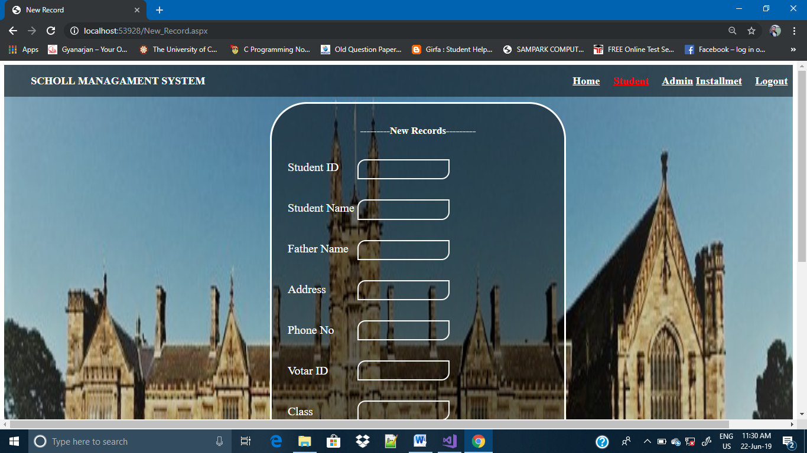

## Page Source:

<%@ Page Language="C#" AutoEventWireup="true" CodeFile="New_Record.aspx.cs" Inherits="New_Record" %>

<!DOCTYPE html PUBLIC "-//W3C//DTD XHTML 1.0 Transitional//EN" "http://www.w3.org/TR/xhtml1/DTD/xhtml1-transitional.dtd">

<html xmlns="http://www.w3.org/1999/xhtml">

<head runat="server">

<title>New Record</title>

<style>

.Background

{

background-image:url(image/bgimage.jpg);

background-size:100% 110%;

background-position:100% 100%;

height:170vh;

width:100%;

}

.Menu

{

background-color:rgba(0,0,0,0.5);

color:White;

height:60px;

width:100%;

}

.leftmenu

{

width:35%;

line-height:60px;

padding-left:50px;

font-size:20px;

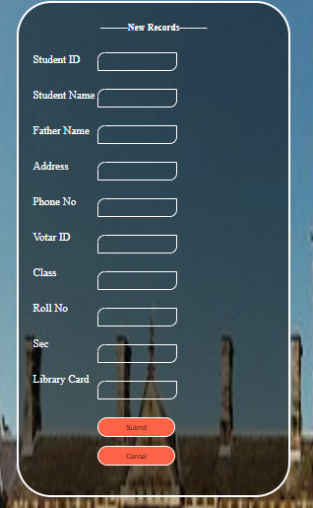 font-weight:bold;

float:left;

}

.rightmenu

{

width:75%;

line-height:60px;

padding-left:500px;

font-size:20px;

font-weight:bold;

}

#HyperLink1

{

margin-left:500px;

}

#HyperLink2

{

margin-left:20px;

}#HyperLink3

{

margin-left:20px;

}#HyperLink4

{

margin-left:20px;

}

.Form

{

height:900px;

width:550px;

margin-left:500px;

margin-top:10px;

background-color:rgba(0,0,0,0.5);

color:White;

border-radius:70px 70px 70px 70px;

border:3px solid #fff;

padding-top:100px;

position:absolute;

}

.text

{

font-size:22px;

padding-left:30px;

padding-top:0px;

float:left;

}

.textBox

{

margin-top:5px;

float:left;

}

#TextBox1

{

height:32px;

width:250px;

background-color:transparent;

border-radius:15px 0px 15px 0px;

border:2px solid #fff;

margin-bottom10px;

}

#TextBox2

{

height:32px;

width:100%;

background-color:transparent;

border-radius:15px 0px 15px 0px;

border:2px solid #fff;

}

#TextBox3

{

height:32px;

width:100%;

background-color:transparent;

border-radius:15px 0px 15px 0px;

border:2px solid #fff;

}

#TextBox4

{

height:32px;

width:100%;

background-color:transparent;

border-radius:15px 0px 15px 0px;

border:2px solid #fff;

}

#TextBox5

{

height:32px;

width:100%;

background-color:transparent;

border-radius:15px 0px 15px 0px;

border:2px solid #fff;

}

#TextBox6

{

height:32px;

width:100%;

background-color:transparent;

border-radius:15px 0px 15px 0px;

border:2px solid #fff;

}

#TextBox7

{

height:32px;

width:100%;

background-color:transparent;

border-radius:15px 0px 15px 0px;

border:2px solid #fff;

}

#TextBox8

{

height:32px;

width:100%;

background-color:transparent;

border-radius:15px 0px 15px 0px;

border:2px solid #fff;

}

#TextBox9

{

height:32px;

width:100%;

background-color:transparent;

border-radius:15px 0px 15px 0px;

border:2px solid #fff;

}

#TextBox10

{

height:32px;

width:100%;

background-color:transparent;

border-radius:15px 0px 15px 0px;

border:2px solid #fff;

}

#TextBox11 {

height: 32px;

width: 100%;

background-color: transparent;

border-radius: 15px 0px 15px 0px;

border: 2px solid #fff;

}

h3{

margin-top:-60px;

}

#Button1

{

width:100%;

height:40px;

background-color:Tomato;

border-radius:40px 40px 40px 40px;

border:2px solid #fff;

}

#Button2

{

width:100%;

height:40px;

background-color:Tomato;

border-radius:40px 40px 40px 40px;

border:2px solid #fff;

}

#HyperLink1

{

}

</style>

</head>

<body>

<form id="form1" runat="server">

<div class="Background">

<div class="Menu">

<div class="leftmenu">

<asp:Label ID="Label1" runat="server" Text="SCHOLL MANAGAMENT SYSTEM"></asp:Label>

</div >

<div class="rightmenu">

<asp:HyperLink ID="HyperLink1" runat="server" ForeColor="White"

NavigateUrl="~/Home.aspx">Home</asp:HyperLink>

<asp:HyperLink ID="HyperLink2" runat="server" ForeColor="red"

NavigateUrl="~/Student.aspx">Student</asp:HyperLink>

<asp:HyperLink ID="HyperLink3" runat="server" ForeColor="White"

NavigateUrl="~/Admin.aspx">Admin</asp:HyperLink>

<asp:HyperLink ID="HyperLink5" runat="server" NavigateUrl="~/Installment.aspx" ForeColor="White">Installmet</asp:HyperLink>

<asp:HyperLink ID="HyperLink4" runat="server" ForeColor="White"

NavigateUrl="~/Login_page.aspx">Logout</asp:HyperLink>

</div>

</div>

<div class="Form">

<center ><h3>---------New Records---------</h3></center>

<div class="text">

<br />

<asp:Label ID="Label11" runat="server" Text="Student ID"></asp:Label>

<br /><br /><br />

<asp:Label ID="Label2" runat="server" Text="Student Name"></asp:Label>

<br /><br /><br />

<asp:Label ID="Label3" runat="server" Text="Father Name"></asp:Label>

<br /><br /><br />

<asp:Label ID="Label4" runat="server" Text="Address"></asp:Label>

<br /><br /><br />

<asp:Label ID="Label5" runat="server" Text="Phone No"></asp:Label>

<br /><br /><br />

<asp:Label ID="Label6" runat="server" Text="Votar ID"></asp:Label>

<br /><br /><br />

<asp:Label ID="Label7" runat="server" Text="Class"></asp:Label>

<br /><br /><br />

<asp:Label ID="Label8" runat="server" Text="Roll No"></asp:Label>

<br /><br /><br />

<asp:Label ID="Label9" runat="server" Text="Sec"></asp:Label>

<br /><br /><br />

<asp:Label ID="Label10" runat="server" Text="Library Card"></asp:Label>

<br /><br />

</div>

<div class="textBox">

<br />

<asp:TextBox ID="TextBox11" runat="server" ForeColor="White"></asp:TextBox>

<br /><br /><br />

<asp:TextBox ID="TextBox2" runat="server" ForeColor="White"></asp:TextBox>

<br /><br /><br />

<asp:TextBox ID="TextBox3" runat="server" ForeColor="White"></asp:TextBox>

<br /><br /><br />

<asp:TextBox ID="TextBox4" runat="server" ForeColor="White"></asp:TextBox>

<br /><br /><br />

<asp:TextBox ID="TextBox5" runat="server" ForeColor="White"></asp:TextBox>

<br /><br /><br />

<asp:TextBox ID="TextBox6" runat="server" ForeColor="White"></asp:TextBox>

<br /><br /><br />

<asp:TextBox ID="TextBox7" runat="server" ForeColor="White"></asp:TextBox>

<br /><br /><br />

<asp:TextBox ID="TextBox8" runat="server" ForeColor="White"></asp:TextBox>

<br /><br /><br />

<asp:TextBox ID="TextBox9" runat="server" ForeColor="White"></asp:TextBox>

<br /><br /><br />

<asp:TextBox ID="TextBox10" runat="server" ForeColor="White"></asp:TextBox>

<br /><br /><br />

<asp:Button ID="Button1" runat="server" Text="Submit" onclick="Button1_Click" />

<br /><br />

<asp:Button ID="Button2" runat="server" Text="Cancel" onclick="Button2_Click" />

<div>

<br />

<asp:Label ID="msg" runat="server" Text=""></asp:Label>

</div>

</div>

</div>

</form>

</body>

</html>

## Program Code’s:

using System;

using System.Collections.Generic;

using System.Linq;

using System.Web;

using System.Web.UI;

using System.Web.UI.WebControls;

using System.Data;

using System.Data.OleDb;

public partial class New_Record : System.Web.UI.Page

{

OleDbConnection con=new OleDbConnection("Provider=Microsoft.Jet.OLEDB.4.0;Data Source="+@"D:\Ritesh Tiwari\ASP\School.mdb");

OleDbCommand com;

protected void Page_Load(object sender, EventArgs e)

{

}

protected void Button1_Click(object sender, EventArgs e)

{

con.Open();

string insert;

try

{

insert = "insert into Student(Student_ID,Student_Name,Father_Name,Address,Phone_No,Votar_ID,Class,Roll_No,Sec,Library_Card) Values('" +

TextBox11.Text + "','" + TextBox2.Text + "','" + TextBox3.Text + "','" + TextBox4.Text + "','" + TextBox5.Text + "','" + TextBox6.Text + "','" + TextBox7.Text + "','" + TextBox8.Text + "','" + TextBox9.Text + "','" + TextBox10.Text + "')";

com = new OleDbCommand(insert, con);

msg.Text = "Record Saved..........";

com.ExecuteNonQuery();

con.Close();

}

catch (Exception d)

{

msg.Text = "" + d;

}

}

protected void Button2_Click(object sender, EventArgs e)

{

Response.Redirect("Student.aspx");

}

}

# Update Records-------

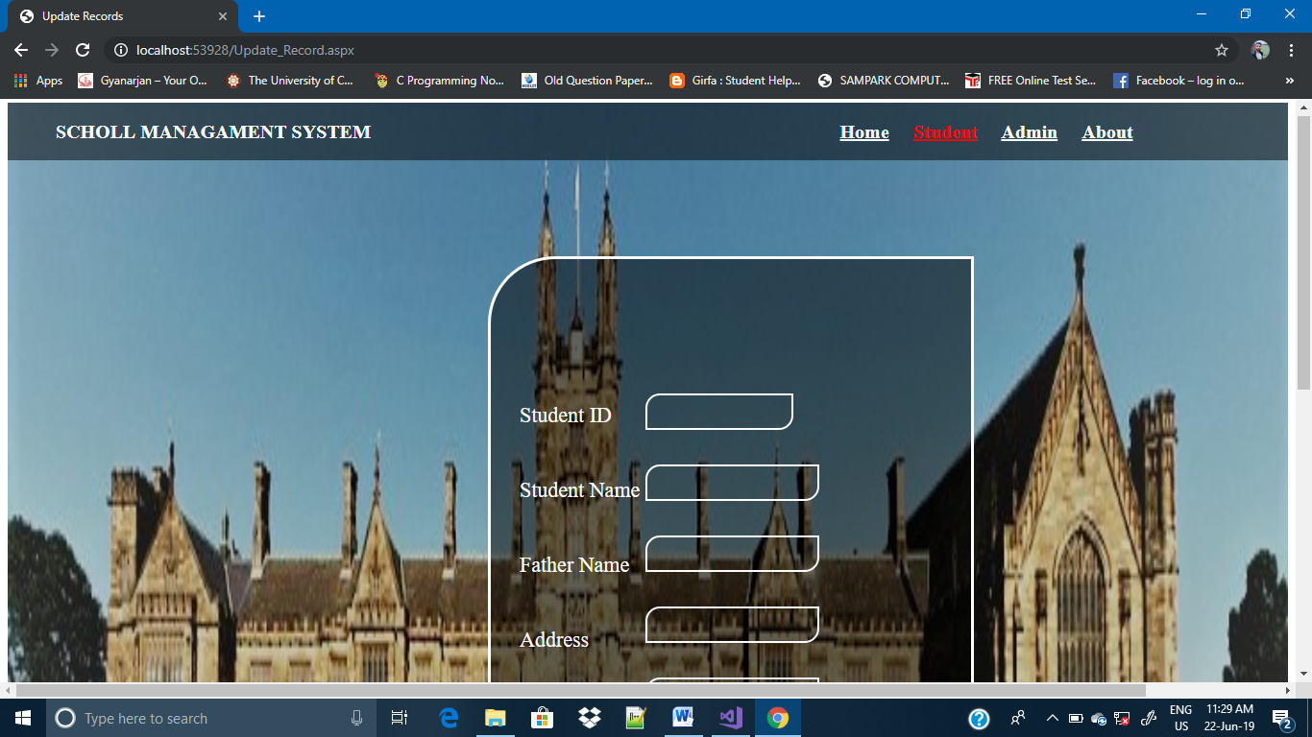

## Page Source:

<%@ Page Language="C#" AutoEventWireup="true" CodeFile="Update_Record.aspx.cs" Inherits="Update_Record" %>

<!DOCTYPE html PUBLIC "-//W3C//DTD XHTML 1.0 Transitional//EN" "http://www.w3.org/TR/xhtml1/DTD/xhtml1-transitional.dtd">

<html xmlns="http://www.w3.org/1999/xhtml">

<head runat="server">

<title>Update Records</title>

<style>

.Background

{

background-image:url(image/bgimage.jpg);

background-size:100% 110%;

background-position:100% 100%;

height:170vh;

width:100%;

}

.Menu

{

background-color:rgba(0,0,0,0.5);

color:White;

height:60px;

width:100%;

}

.leftmenu

{

width:35%;

line-height:60px;

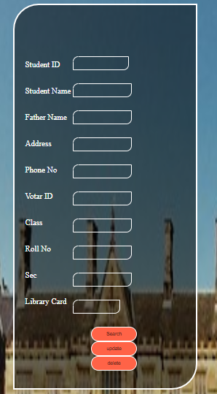 padding-left:50px;

font-size:20px;

font-weight:bold;

float:left;

}

.rightmenu

{

width:75%;

line-height:60px;

padding-left:500px;

font-size:20px;

font-weight:bold;

}

#HyperLink1

{

margin-left:350px;

}

#HyperLink2

{

margin-left:20px;

}#HyperLink3

{

margin-left:20px;

}#HyperLink4

{

margin-left:20px;

}

#HyperLink4

{

margin-left:20px;

}

.Form

{

height:950px;

width:500px;

margin-left:500px;

margin-top:100px;

background-color:rgba(0,0,0,0.5);

color:White;

border-radius:70px 0px 70px 0px;

border:3px solid #fff;

padding-top:100px;

position:absolute;

}

.text

{

font-size:22px;

padding-left:30px;

padding-top:50px;

float:left;

}

.textBox

{

margin-top:40px;

float:left;

}

#TextBox1

{

height:32px;

width:150px;

background-color:transparent;

border-radius:15px 0px 15px 0px;

border:2px solid #fff;

margin-bottom10px;

}

#TextBox2

{

height:32px;

width:100%;

background-color:transparent;

border-radius:15px 0px 15px 0px;

border:2px solid #fff;

}

#TextBox3

{

height:32px;

width:100%;

background-color:transparent;

border-radius:15px 0px 15px 0px;

border:2px solid #fff;

}

#TextBox4

{

height:32px;

width:100%;

background-color:transparent;

border-radius:15px 0px 15px 0px;

border:2px solid #fff;

}

#TextBox5

{

height:32px;

width:100%;

background-color:transparent;

border-radius:15px 0px 15px 0px;

border:2px solid #fff;

}

#TextBox6

{

height:32px;

width:100%;

background-color:transparent;

border-radius:15px 0px 15px 0px;

border:2px solid #fff;

}

#TextBox7

{

height:32px;

width:100%;

background-color:transparent;

border-radius:15px 0px 15px 0px;

border:2px solid #fff;

}

#TextBox8

{

height:32px;

width:100%;

background-color:transparent;

border-radius:15px 0px 15px 0px;

border:2px solid #fff;

}

#TextBox9

{

height:32px;

width:100%;

background-color:transparent;

border-radius:15px 0px 15px 0px;

border:2px solid #fff;

}

#TextBox10

{

height:32px;

width:80%;

background-color:transparent;

border-radius:15px 0px 15px 0px;

border:2px solid #fff;

}

#Button2

{

margin-left:50px;

width:80%;

height:40px;

background-color:Tomato;

border-radius:40px 40px 40px 40px;

border:2px solid #fff;

}

#Button3

{

margin-left:50px;

width:80%;

height:40px;

background-color:Tomato;

border-radius:40px 40px 40px 40px;

border:2px solid #fff;

}

#Button1

{

margin-left:50px;

width:80%;

height:40px;

background-color:Tomato;

border-radius:40px 40px 40px 40px;

border:2px solid #fff;

}

#HyperLink1

{

}

</style>

</head>

<body>

<form id="form1" runat="server">

<div class="Background">

<div class="Menu">

<div class="leftmenu">

<asp:Label ID="Label1" runat="server" Text="SCHOLL MANAGAMENT SYSTEM"></asp:Label>

</div >

<div class="rightmenu">

<asp:HyperLink ID="HyperLink1" runat="server" ForeColor="White"

NavigateUrl="~/Home.aspx">Home</asp:HyperLink>

<asp:HyperLink ID="HyperLink2" runat="server" ForeColor="red"

NavigateUrl="~/Student.aspx">Student</asp:HyperLink>

<asp:HyperLink ID="HyperLink3" runat="server" ForeColor="White"

NavigateUrl="~/Admin.aspx">Admin</asp:HyperLink>

<asp:HyperLink ID="HyperLink4" runat="server" ForeColor="White"

NavigateUrl="~/About.aspx">About</asp:HyperLink>

</div>

<div class="Form">

<div class="text">

<asp:Label ID="Label11" runat="server" Text="Student ID"></asp:Label>

<br /><br /><br />

<asp:Label ID="Label2" runat="server" Text="Student Name"></asp:Label>

<br /><br /><br />

<asp:Label ID="Label3" runat="server" Text="Father Name"></asp:Label>

<br /><br /><br />

<asp:Label ID="Label4" runat="server" Text="Address"></asp:Label>

<br /><br /><br />

<asp:Label ID="Label5" runat="server" Text="Phone No"></asp:Label>

<br /><br /><br />

<asp:Label ID="Label6" runat="server" Text="Votar ID"></asp:Label>

<br /><br /><br />

<asp:Label ID="Label7" runat="server" Text="Class"></asp:Label>

<br /><br /><br />

<asp:Label ID="Label8" runat="server" Text="Roll No"></asp:Label>

<br /><br /><br />

<asp:Label ID="Label9" runat="server" Text="Sec"></asp:Label>

<br /><br /><br />

<asp:Label ID="Label10" runat="server" Text="Library Card"></asp:Label>

<br /><br />

</div>

<div class="textBox">

<asp:TextBox ID="TextBox1" runat="server" ForeColor="White"></asp:TextBox>

<br /><br /><br />

<asp:TextBox ID="TextBox2" runat="server" ForeColor="White"></asp:TextBox>

<br /><br /><br />

<asp:TextBox ID="TextBox3" runat="server" ForeColor="White"></asp:TextBox>

<br /><br /><br />

<asp:TextBox ID="TextBox4" runat="server" ForeColor="White"></asp:TextBox>

<br /><br /><br />

<asp:TextBox ID="TextBox5" runat="server" ForeColor="White"></asp:TextBox>

<br /><br /><br />

<asp:TextBox ID="TextBox6" runat="server" ForeColor="White"></asp:TextBox>

<br /><br /><br />

<asp:TextBox ID="TextBox7" runat="server" ForeColor="White"></asp:TextBox>

<br /><br /><br />

<asp:TextBox ID="TextBox8" runat="server" ForeColor="White"></asp:TextBox>

<br /><br /><br />

<asp:TextBox ID="TextBox9" runat="server" ForeColor="White"></asp:TextBox>

<br /><br /><br />

<asp:TextBox ID="TextBox10" runat="server" ForeColor="White"></asp:TextBox>

<br /><br /><br />

<asp:Button ID="Button1" runat="server" Text="Search" onclick="Button1_Click" />

<br />

<asp:Button ID="Button2" runat="server" Text="update" onclick="Button2_Click" />

<br />

<asp:Button ID="Button3" runat="server" Text="delete" onclick="Button3_Click" />

<div>

<br />

<asp:Label ID="msg" runat="server" Text=""></asp:Label>

</div>

</div>

</div>

</div>

</div>

</form>

</body>

</html>

## Program Code’s:

using System;

using System.Collections.Generic;

using System.Linq;

using System.Web;

using System.Web.UI;

using System.Web.UI.WebControls;

using System.Data.OleDb;

using System.Data;

public partial class Update_Record : System.Web.UI.Page

{

OleDbConnection con = new OleDbConnection("Provider=Microsoft.Jet.OLEDB.4.0;Data Source=" + @"D:\Ritesh Tiwari\ASP\School.mdb");

OleDbCommand com;

OleDbDataAdapter da;

DataSet ds;

protected void Page_Load(object sender, EventArgs e)

{

}

protected void Button1_Click(object sender, EventArgs e)

{

string search;

search = "select *from Student where Student_ID='" + TextBox1.Text + "'";

com = new OleDbCommand(search, con);

da = new OleDbDataAdapter(com);

ds = new DataSet();

da.Fill(ds);

if (ds.Tables[0].Rows.Count > 0)

{

TextBox2.Text = ds.Tables[0].Rows[0][1].ToString();

TextBox3.Text = ds.Tables[0].Rows[0][2].ToString();

TextBox4.Text = ds.Tables[0].Rows[0][3].ToString();

TextBox5.Text = ds.Tables[0].Rows[0][4].ToString();

TextBox6.Text = ds.Tables[0].Rows[0][5].ToString();

TextBox7.Text = ds.Tables[0].Rows[0][6].ToString();

TextBox8.Text = ds.Tables[0].Rows[0][7].ToString();

TextBox9.Text = ds.Tables[0].Rows[0][8].ToString();

TextBox10.Text = ds.Tables[0].Rows[0][9].ToString();

msg.Text = "Record found...........";

}

else

{

TextBox2.Text = "";

TextBox3.Text = "";

TextBox4.Text = "";

TextBox5.Text = "";

TextBox6.Text = "";

TextBox7.Text = "";

TextBox8.Text = "";

TextBox9.Text = "";

TextBox10.Text = "";

}

}

protected void Button2_Click(object sender, EventArgs e)

{

string update;

con.Open();

update = "update Student set Student_Name='" + TextBox2.Text + "',Father_Name='" + TextBox3.Text + "',Address='" + TextBox4.Text + "',Phone_No='" + TextBox5.Text + "',Votar_ID='" + TextBox6.Text + "',Class='" + TextBox7.Text + "',Roll_No='" + TextBox8.Text + "',Sec='" + TextBox9.Text + "',Library_card='" + TextBox10.Text + "' where Student_ID='" + TextBox1.Text + "'";

com = new OleDbCommand(update, con);

com.ExecuteNonQuery();

msg.Text = "Record Update";

TextBox2.Text = "";

TextBox3.Text = "";

TextBox4.Text = "";

TextBox5.Text = "";

TextBox6.Text = "";

TextBox7.Text = "";

TextBox8.Text = "";

TextBox9.Text = "";

TextBox10.Text = "";

}

protected void Button3_Click(object sender, EventArgs e)

{

string delete;

con.Open();

delete = "Delete from Student where Student_ID='" + TextBox1.Text + "'";

com = new OleDbCommand(delete, con);

com.ExecuteNonQuery();

msg.Text = "record delete";

TextBox2.Text = "";

TextBox3.Text = "";

TextBox4.Text = "";

TextBox5.Text = "";

TextBox6.Text = "";

TextBox7.Text = "";

TextBox8.Text = "";

TextBox9.Text = "";

TextBox10.Text = "";

}

}

# Installment page----------

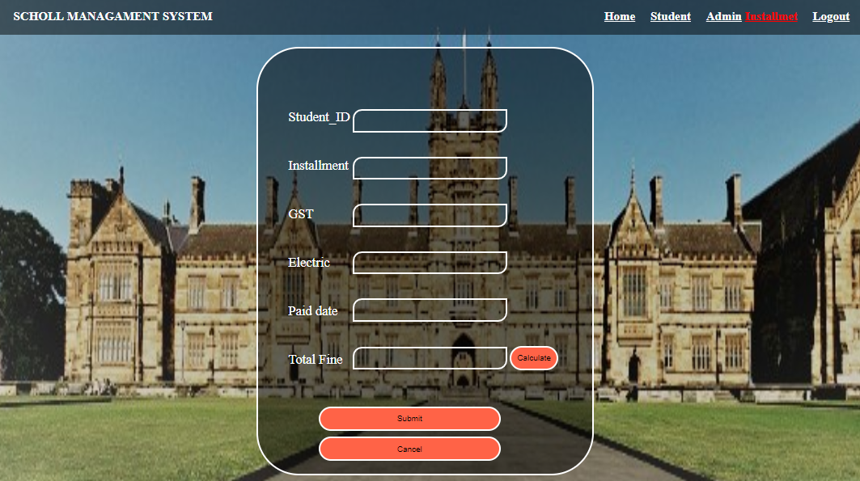

## Page Source:

<%@ Page Language="C#" AutoEventWireup="true" CodeFile="Installment.aspx.cs" Inherits="Fess" %>

<!DOCTYPE html PUBLIC "-//W3C//DTD XHTML 1.0 Transitional//EN" "http://www.w3.org/TR/xhtml1/DTD/xhtml1-transitional.dtd">

<html xmlns="http://www.w3.org/1999/xhtml">

<head runat="server">

<title>installment</title>

<style>

.Background

{

background-image:url(image/bgimage.jpg);

background-size:100% 110%;

background-position:100% 100%;

height:100vh;

width:100%;

}

.Menu

{

background-color:rgba(0,0,0,0.5);

color:White;

height:60px;

width:100%;

}

.leftmenu

{

width:35%;

line-height:60px;

padding-left:50px;

font-size:20px;

font-weight:bold;

float:left;

}

.rightmenu

{

width:75%;

line-height:60px;

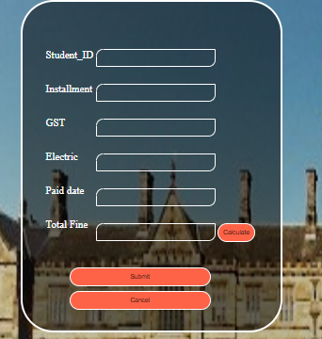 padding-left:500px;

font-size:20px;

font-weight:bold;

}

#HyperLink1

{

margin-left:350px;

}

#HyperLink2

{

margin-left:20px;

}#HyperLink3

{

margin-left:20px;

}#HyperLink4

{

margin-left:20px;

}

#HyperLink4

{

margin-left:20px;

}

.form

{

height:600px;

width:550px;

margin-left:450px;

margin-top:20px;

background-color:rgba(0,0,0,0.5);

color:White;

border-radius:70px 70px 70px 70px;

border:3px solid #fff;

padding-top:100px;

position:absolute;

}

.text

{

margin-left:50px;

float:left;

font-size:22px;

}

.textBox

{

margin-left:40px;

}

#TextBox1

{

height:32px;

width:250px;

background-color:transparent;

border-radius:15px 0px 15px 0px;

border:2px solid #fff;

margin-bottom10px;

}

#TextBox2

{

height:32px;

width:250px;

background-color:transparent;

border-radius:15px 0px 15px 0px;

border:2px solid #fff;

}

#TextBox3

{

height:32px;

width:250px;

background-color:transparent;

border-radius:15px 0px 15px 0px;

border:2px solid #fff;

}

#TextBox4

{

height:32px;

width:250px;

background-color:transparent;

border-radius:15px 0px 15px 0px;

border:2px solid #fff;

}

#TextBox5

{

height:32px;

width:250px;

background-color:transparent;

border-radius:15px 0px 15px 0px;

border:2px solid #fff;

}

#TextBox6

{

height:32px;

width:250px;

background-color:transparent;

border-radius:15px 0px 15px 0px;

border:2px solid #fff;

}

#Button4

{

margin-left:60px;

margin-bottom:10px;

width:300px;

height:40px;

background-color:Tomato;

border-radius:40px 40px 40px 40px;

border:2px solid #fff;

}

#Button2

{

margin-left:60px;

margin-bottom:10px;

width:300px;

height:40px;

background-color:Tomato;

border-radius:40px 40px 40px 40px;

border:2px solid #fff;

}

#Button1

{

width:80px;

height:40px;

background-color:Tomato;

border-radius:20px 20px 20px 20px;

border:2px solid #fff;

}

</style>

</head>

<body>

<form id="form1" runat="server">

<div class="Background">

<div class="Menu">

<div class="leftmenu">

<asp:Label ID="Label1" runat="server" Text="SCHOLL MANAGAMENT SYSTEM"></asp:Label>

</div >

<div class="rightmenu">

<asp:HyperLink ID="HyperLink1" runat="server" ForeColor="White"

NavigateUrl="~/Home.aspx">Home</asp:HyperLink>

<asp:HyperLink ID="HyperLink2" runat="server" ForeColor="White"

NavigateUrl="~/Student.aspx">Student</asp:HyperLink>

<asp:HyperLink ID="HyperLink3" runat="server" ForeColor="White"

NavigateUrl="~/Admin.aspx">Admin</asp:HyperLink>

<asp:HyperLink ID="HyperLink5" runat="server" NavigateUrl="~/Installment.aspx" ForeColor="red">Installmet</asp:HyperLink>

<asp:HyperLink ID="HyperLink4" runat="server" ForeColor="White"

NavigateUrl="~/Login_page.aspx">Logout</asp:HyperLink>

</div>

</div>

<div class="form">

<div class="text">

<asp:Label ID="Label2" runat="server" Text="Student_ID"></asp:Label>

<br /><br /><br />

<asp:Label ID="Label3" runat="server" Text="Installment"></asp:Label>

<br /><br /><br />

<asp:Label ID="Labe4" runat="server" Text="GST"></asp:Label>

<br /><br /><br />

<asp:Label ID="Labe5" runat="server" Text="Electric"></asp:Label>

<br /><br /><br />

<asp:Label ID="Label6" runat="server" Text="Paid date"></asp:Label>

<br /><br /><br />

<asp:Label ID="Label7" runat="server" Text="Total Fine"></asp:Label>

</div>

<div class="textBox">

<asp:TextBox ID="TextBox1" runat="server" ></asp:TextBox>

<br /><br/><br />

<asp:TextBox ID="TextBox2" runat="server"></asp:TextBox>

<br /><br /><br />

<asp:TextBox ID="TextBox3" runat="server"></asp:TextBox>

<br /><br /><br />

<asp:TextBox ID="TextBox4" runat="server"></asp:TextBox>

<br /><br /><br />

<asp:TextBox ID="TextBox5" runat="server" ></asp:TextBox>

<br /><br /><br />

<asp:TextBox ID="TextBox6" runat="server"></asp:TextBox>

<asp:Button ID="Button1" runat="server" onclick="Button3_Click1"

Text="Calculate" />

<br />

<br /><br /><br />

<asp:Button ID="Button2" runat="server" Text="Submit" onclick="Button2_Click" />

<br />

<asp:Button ID="Button4" runat="server" onclick="Button4_Click"

Text="Cancel" />

<br />

<br />

<asp:Label ID="msg" runat="server" Text=""></asp:Label>

</div>

</div>

</form>

</body>

</html>

## Program codes:

using System;

using System.Collections.Generic;

using System.Linq;

using System.Web;

using System.Web.UI;

using System.Web.UI.WebControls;

using System.Data.OleDb;

using System.Data;

public partial class Fess : System.Web.UI.Page

{

OleDbConnection con = new OleDbConnection("Provider=Microsoft.Jet.OLEDB.4.0;Data Source=" + @"D:\Ritesh Tiwari\ASP\School.mdb");

OleDbCommand com;

OleDbDataAdapter da;

DataSet ds;

protected void Page_Load(object sender, EventArgs e)

{

}

protected void Button2_Click(object sender, EventArgs e)

{

con.Open();

string insert;

insert = "insert into Installment (Student_ID,Installment,GST,Electric,Paid_Date,Total_Fine) Values('" +

TextBox1.Text + "','" + TextBox2.Text+ "','" +TextBox3.Text+ "','" + TextBox4.Text + "','" + TextBox5.Text + "','" + TextBox6.Text +"')";

com = new OleDbCommand(insert, con);

msg.Text = "Record Saved..........";

com.ExecuteNonQuery();

con.Close();

}

protected void Button3_Click(object sender, EventArgs e)

{

}

protected void Button3_Click1(object sender, EventArgs e)

{

double installmant, GST, electric, fine, total;

installmant=Convert.ToDouble(TextBox1.Text);

GST=Convert.ToDouble(TextBox3.Text);

electric = Convert.ToDouble(TextBox4.Text);

total = installmant + GST/100 + electric;

TextBox6.Text = "" + total.ToString();

}

protected void Button4_Click(object sender, EventArgs e)

{

TextBox2.Text = "";

TextBox3.Text = "";

TextBox4.Text = "";

TextBox5.Text = "";

TextBox6.Text = "";

TextBox1.Text = "";

}

}

# User Page-------------

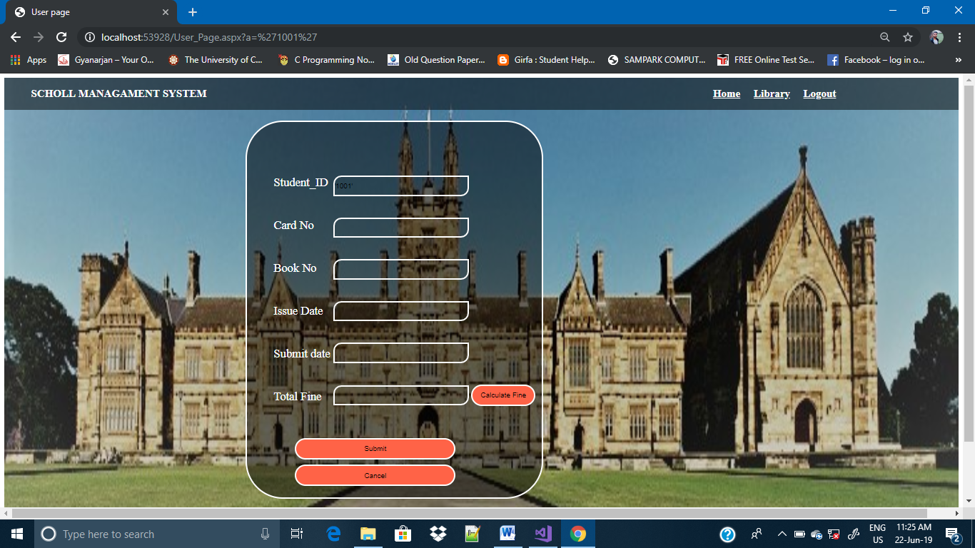

## Page Source:

<%@ Page Language="C#" AutoEventWireup="true" CodeFile="User_Page.aspx.cs" Inherits="User_Page" %>

<!DOCTYPE html PUBLIC "-//W3C//DTD XHTML 1.0 Transitional//EN" "http://www.w3.org/TR/xhtml1/DTD/xhtml1-transitional.dtd">

<html xmlns="http://www.w3.org/1999/xhtml">

<head runat="server">

<title>User page</title>

<style>

.Background

{

background-image:url(image/bgimage.jpg);

background-size:100% 110%;

background-position:100% 100%;

height:110vh;

width:100%;

}

.Menu

{

background-color:rgba(0,0,0,0.5);

color:White;

height:60px;

width:100%;

}

.leftmenu

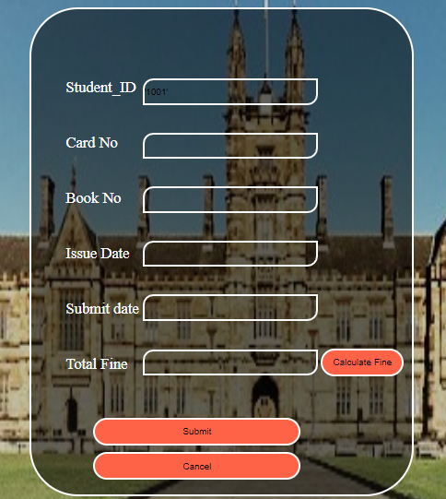 {

width:35%;

line-height:60px;

padding-left:50px;

font-size:20px;

font-weight:bold;

float:left;

}

.rightmenu

{

width:75%;

line-height:60px;

padding-left:500px;

font-size:20px;

font-weight:bold;

}

#HyperLink1

{

margin-left:650px;

}

#HyperLink2

{

margin-left:20px;

}#HyperLink3

{

margin-left:20px;

}#HyperLink4

{

margin-left:20px;

}

.form

{

height:600px;

width:550px;

margin-left:450px;

margin-top:10px;

background-color:rgba(0,0,0,0.5);

color:White;

border-radius:70px 70px 70px 70px;

border:3px solid #fff;

padding-top:100px;

position:absolute;

}

.text

{

margin-left:50px;

float:left;

font-size:22px;

}

.textBox

{

margin-left:30px;

}

#TextBox1

{

height:32px;

width:250px;

background-color:transparent;

border-radius:15px 0px 15px 0px;

border:2px solid #fff;

margin-bottom10px;

}

#TextBox2

{

height:32px;

width:250px;

background-color:transparent;

border-radius:15px 0px 15px 0px;

border:2px solid #fff;

}

#TextBox3

{

height:32px;

width:250px;

background-color:transparent;

border-radius:15px 0px 15px 0px;

border:2px solid #fff;

}

#TextBox4

{

height:32px;

width:250px;

background-color:transparent;

border-radius:15px 0px 15px 0px;

border:2px solid #fff;

}

#TextBox5

{

height:32px;

width:250px;

background-color:transparent;

border-radius:15px 0px 15px 0px;

border:2px solid #fff;

}

#TextBox6

{

height:32px;

width:250px;

background-color:transparent;

border-radius:15px 0px 15px 0px;

border:2px solid #fff;

}

#Button4

{

margin-left:60px;

margin-bottom:10px;

width:300px;

height:40px;

background-color:Tomato;

border-radius:40px 40px 40px 40px;

border:2px solid #fff;

}

#Button2

{

margin-left:60px;

margin-bottom:10px;

width:300px;

height:40px;

background-color:Tomato;

border-radius:40px 40px 40px 40px;

border:2px solid #fff;

}

#Button5

{

width:120px;

height:40px;

background-color:Tomato;

border-radius:20px 20px 20px 20px;

border:2px solid #fff;

}

</style>

</head>

<body>

<form id="form1" runat="server">

<div class="Background">

<div class="Menu">

<div class="leftmenu">

<asp:Label ID="Label1" runat="server" Text="SCHOLL MANAGAMENT SYSTEM"></asp:Label>

</div >

<div class="rightmenu">

<asp:HyperLink ID="HyperLink1" runat="server" ForeColor="White"

NavigateUrl="~/Home.aspx">Home</asp:HyperLink>

<asp:HyperLink ID="HyperLink2" runat="server" ForeColor="White"

NavigateUrl="~/Student.aspx">Library</asp:HyperLink>

<asp:HyperLink ID="HyperLink4" runat="server" ForeColor="White"

NavigateUrl="~/Login_page.aspx">Logout</asp:HyperLink>

</div>

</div>

<div class="form">

<div class="text">

<asp:Label ID="Label2" runat="server" Text="Student_ID"></asp:Label>

<br /><br /><br />

<asp:Label ID="Label3" runat="server" Text="Card No"></asp:Label>

<br /><br /><br />

<asp:Label ID="Labe4" runat="server" Text="Book No"></asp:Label>

<br /><br /><br />

<asp:Label ID="Labe5" runat="server" Text="Issue Date"></asp:Label>

<br /><br /><br />

<asp:Label ID="Label6" runat="server" Text="Submit date"></asp:Label>

<br /><br /><br />

<asp:Label ID="Label7" runat="server" Text="Total Fine"></asp:Label>

</div>

<div class="textBox">

<asp:TextBox ID="TextBox1" runat="server" ></asp:TextBox>

<br /><br/><br />

<asp:TextBox ID="TextBox2" runat="server"></asp:TextBox>

<br /><br /><br />

<asp:TextBox ID="TextBox3" runat="server"></asp:TextBox>

<br /><br /><br />

<asp:TextBox ID="TextBox4" runat="server"></asp:TextBox>

<br /><br /><br />

<asp:TextBox ID="TextBox5" runat="server" ></asp:TextBox>

<br /><br /><br />

<asp:TextBox ID="TextBox6" runat="server"></asp:TextBox>

<asp:Button ID="Button5" runat="server" Text="Calculate Fine"

onclick="Button5_Click" />

<br />

<br /><br /><br />

<asp:Button ID="Button2" runat="server" Text="Submit" onclick="Button2_Click" />

<br />

<asp:Button ID="Button4" runat="server" onclick="Button4_Click"

Text="Cancel" />

<br />

<br />

<asp:Label ID="msg" runat="server" Text=""></asp:Label>

</div>

</div>

</form>

</body>

</html>

## Programs codes:

using System;

using System.Collections.Generic;

using System.Linq;

using System.Web;

using System.Web.UI;

using System.Web.UI.WebControls;

using System.Data.OleDb;

using System.Data;

public partial class User_Page : System.Web.UI.Page

{

OleDbConnection con = new OleDbConnection("Provider=Microsoft.Jet.OLEDB.4.0;Data Source=" + @"D:\Ritesh Tiwari\ASP\School.mdb");

OleDbCommand com;

OleDbDataAdapter da;

DataSet ds;

protected void Page_Load(object sender, EventArgs e)

{

string student;

student = Request.QueryString["a"].ToString();

TextBox1.Text = "" + student;

}

protected void Button5_Click(object sender, EventArgs e)

{

string update;

update = "update Library Card_No='" + TextBox2.Text + "',Book_No='" + TextBox3.Text + "',Issue_Date='" + TextBox4.Text + "',Submit_Date='" + TextBox5.Text + "',Total_Fine='" + TextBox6.Text + "' where Student_ID='" + TextBox1.Text + "'";

com = new OleDbCommand(update, con);

com.ExecuteNonQuery();

msg.Text = "Record Update";

TextBox2.Text = "";

TextBox3.Text = "";

TextBox4.Text = "";

TextBox5.Text = "";

TextBox6.Text = "";

}

protected void Button2_Click(object sender, EventArgs e)

{

}

protected void Button4_Click(object sender, EventArgs e)

{

}

}